FORM 2

THE PATENTS ACT, 1970

(39 of 1970) &

THE PATENTS RULES, 2003

COMPLETE SPECIFICATION

1. **TITLE OF THE INVENTION**

**COUNTERFEIT DETECTION SYSTEM**

1. **APPLICANT(S)**
2. **Name –** Archit Rajesh Srivastava

**Nationality –** Indian

**Address –** Kiet Group Of Institutions , Ghaziabad,

Uttar Pradesh, India – 201206

1. **Name –** Bhoomika Saxena

**Nationality –** Indian

**Address –** Kiet Group Of Institutions , Ghaziabad,

Uttar Pradesh, India – 201206

1. **Name –** Ankita Jain

**Nationality –** Indian

**Address –** Kiet Group Of Institutions , Ghaziabad,

Uttar Pradesh, India – 201206

1. **PREAMBLE TO DESCRIPTION**

COMPLETE SPECIFICATION – The following specification describes the invention and the manner in which it is to be performed.

**Field of the Invention**

**[0001]** The present invention relates to a system and method to check the originality of the cloth brand or label. A system for tracing the duplicate product comprising of QR Code, Unique identification mark (UIDM), the UIDM reader, UIDM reader web application, the database of UIDM and manufacturer details .

**Background**

**[0002]** The background description includes information that may be useful in understanding the present invention. It is not an admission that any of the information provided herein is prior art or relevant to the presently claimed invention, or that any publication specifically or implicitly referenced is prior art.

**[0003]** At the time of shopping clothing products, there is a possibility that people get fake products in the name of a renowned brand by paying the amount of the original one and sometimes it becomes difficult for the customer to decide whether it is real or fake.

**[0004]** Counterfeit products have become a widespread problem, causing significant losses to companies and affecting consumer’s trust.

**[0005]** Hence this malpractice of counterfeiting on clothing industry leads to divert the revenue generated from its legitimate manufacturers and retailers.

**[0006]** Also it leads to doping of allergenic materials, causing health risks to customers and many manufacturers involving in counterfeit of products do not adhere to eco-friendly practices.

**[0007]** To address this issue, a system is required to verify the authenticity of these products using a QR code associated with a unique product ID.

**[0008]** The system aims to reduce the loss of companies due to counterfeiting , uphold the reputation of authentic brands, and ensure that the government receives tax percentage from transactions involving clothing products.

**[0009]** The market cap of fake clothing products in the year 2021 was over 1 billion. In India alone it is growing rapidly at about 20% increase every year.

**[0010]** Overall, the Counterfeit Detection System is a significant step towards making shopping counterfeit-free and ensuring that consumers get what they pay for.

**Objectives of the Invention**

**[0011]** An object of present disclosure is to detect whether a clothing product is authentic or counterfeit.

**[0012]** An object of present invention is to fetch details of product at the time of purchase, including authenticity approved by the brand, original price, sold status and supply chain.

**[0013]** An object of present invention is to alert the user and the company if the QR code is invalid or the product is resold.

**[0014]** An object of present disclosure is to reduce the loss of the company due to counterfeiting clothing products.

**[0015]** An object of the system is to uphold the authentic brand’s reputation.

**[0016]** An object of present disclosure is to ensure the government receives the tax percentage by the transaction of purchase of clothing products.

**[0017]** An object of present system is to create a counterfeit-free shopping experience for customers.

**Summary**

**[0018]** A system for tracing the duplicate product supply, the system comprising of a QR code associated with unique ID of product where while scanning it will show various details about the company and all the necessary information like whether the product is sold before or not, manufacturing place, manufacturer name, details about the product, etc.

**[0019]** The QR is connected to the database of the company. Once the product is bought by the retailer from the company, the retailer has to feed the information about the company at the backend of the QR.

**[0020]** The consumer, while buying, would need to scan it. If the QR is valid, it would redirect customer to the company’s website and customer will get the required details.

**[0021]** If the product is new or not sold before, the customer will be able to write reviews about it and if the product is already sold before, it will generate alert and it will let the company to uphold the enquiry against the seller.

**[0022]** The present invention leads to sell a specific product having unique product ID only once and hence once the product is sold already, it would automatically update at the backend of the company.

**Drawings :-**

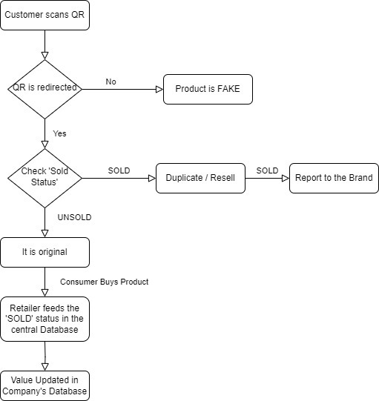

FIG.1

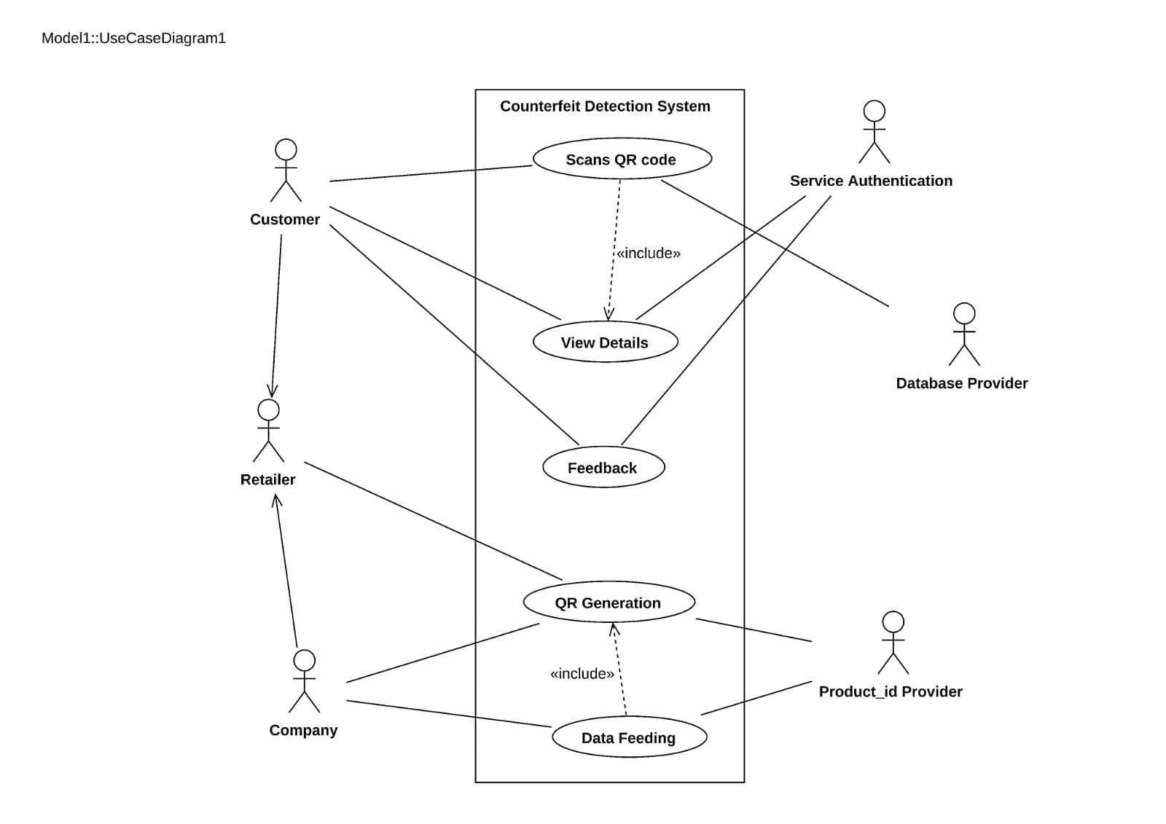

FIG.2

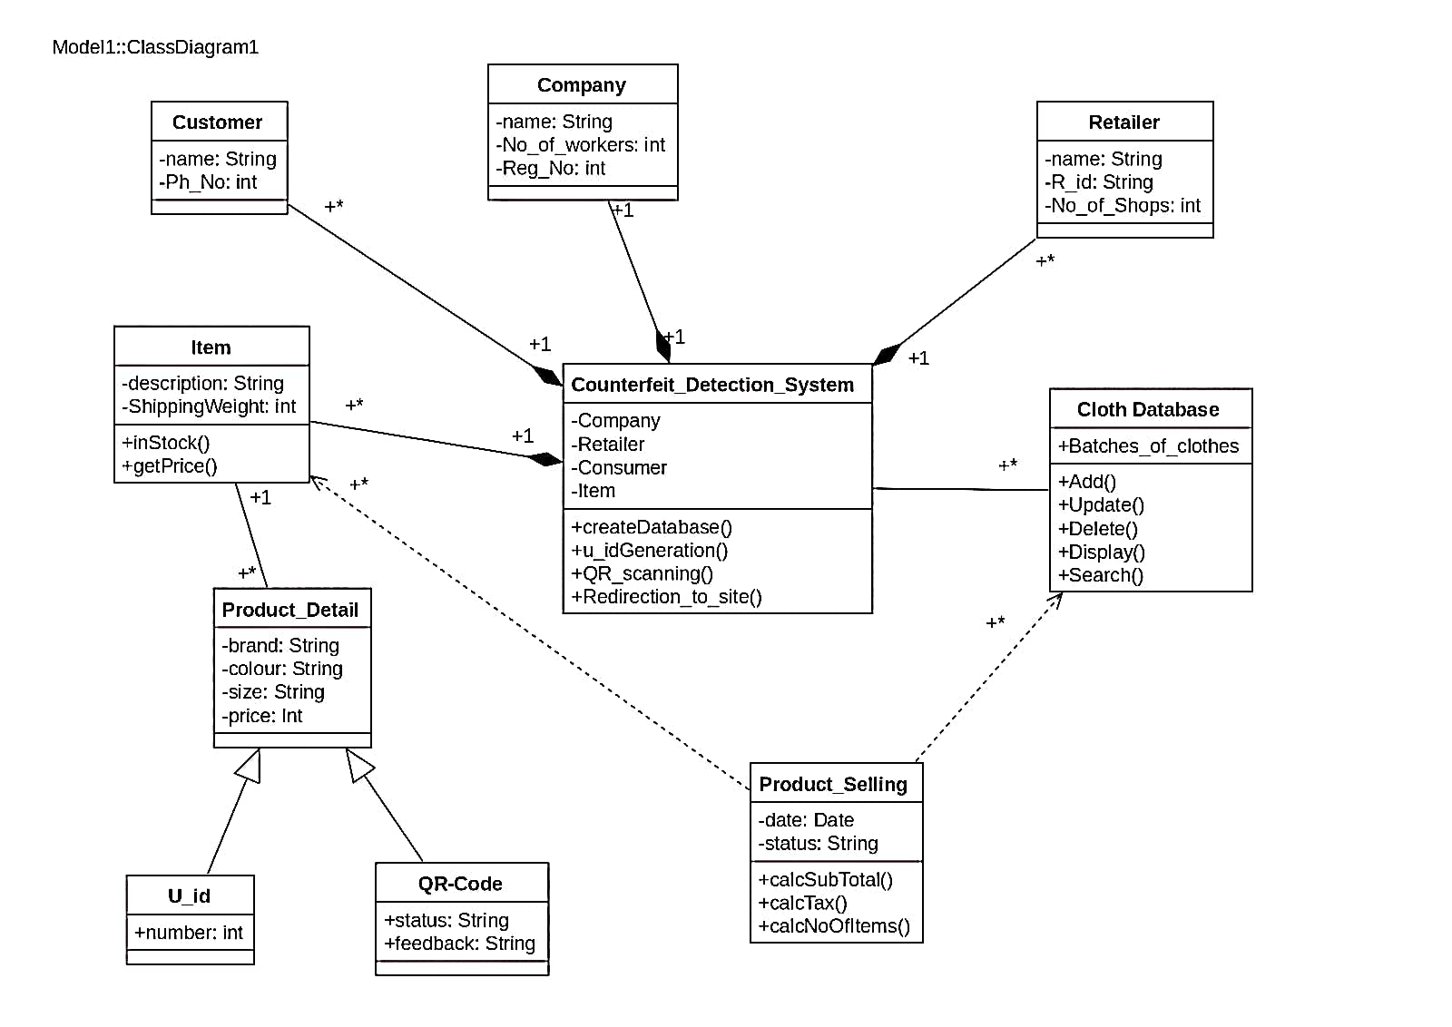

FIG.3

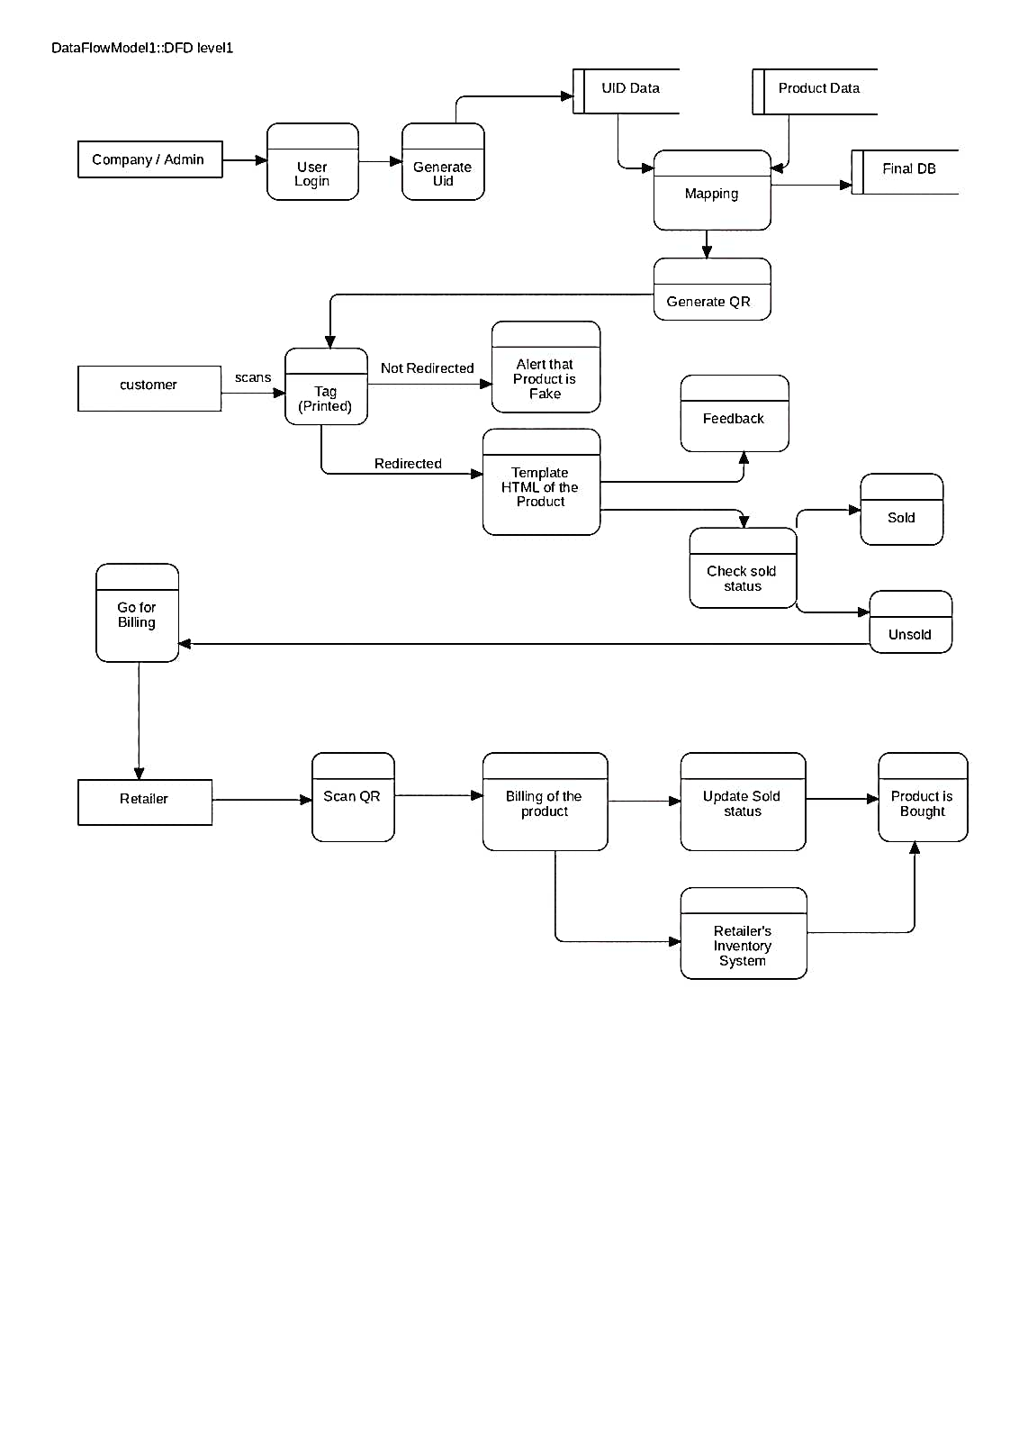

FIG.4

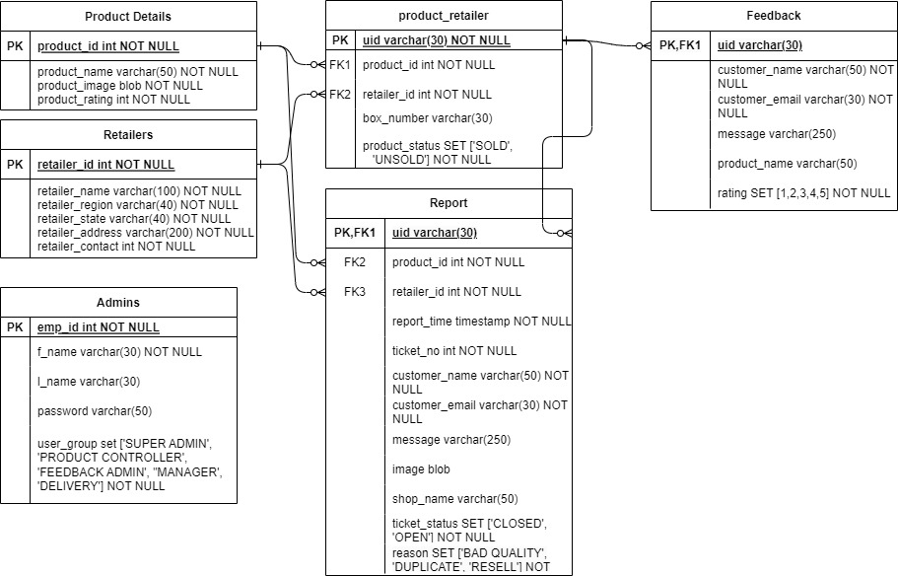

FIG. 5

**Brief Description of Drawings**

**[0023]** FIG.1 illustrates the data flow diagram of a system for detecting duped version of branded clothes, in accordance with an embodiment of the present disclosure.

**[0024]** FIG.2 illustrates an exemplary representation showing detailed Used Case Diagram for determining counterfeited clothes, in accordance with embodiments of the present disclosure.

**[0025]** FIG.3 illustrates the class diagram of the entire disclosure.

**[0026]** FIG.4 is the level 1 DFD representation of the present disclosure.

**Detailed Description**

**[0027]** In FIG.1, the present invention shows the scenario where the customer coming to buy the product has to scan the QR code given on the tag of the clothing product.

**[0028]** Now the scanned QR code will show the details of the product if it is already sold or not.

**[0029]** Now the customer will check the sold status of the product, if it is showing “SOLD” , it means the product is fake or the duped version of the branded cloth.

**[0030]** If it is showing the status as “UNSOLD” the customer will be redirected to the product details page of the product where various details like size, color, fabric, manufacturing details of the product will be shown.

**[0031]** Now the customer can write the feedback of the product and after buying the product the status of product is modified as “SOLD” at the backend of database.

**[0032]** Fig.2 is the Used Case Diagram of the present system.

**[0033]** Fig.3 is the Class Diagram of the present disclosure representing the same process.

**[0034]** Fig.4 is the level 1 DFD of the present system.

**Advantages of the Invention**

**[0035]** An advantage of the present disclosure is the authentication of branded products.

**[0036]** An advantage of the present disclosure is the enhancement of customer satisfaction and trust.

**[0037]** An advantage of the present invention is the increased tax revenue generated for government

**[0038]** An advantage of the present invention is the improvement in supply chain transparency.

**[0039]** An advantage of the present disclosure is to provide standard materials to the customers and to enhance consumer safety.

**Claims**

We Claim:

1. A system for tracing the dupe of branded clothes, the system comprising of:

QR Code, Unique identification mark (UIDM), the UIDM reader, UIDM reader web application, the database of UIDM.

* The QR code has all the details about manufactures, dealers, whole sellers and retailers.
* The UIDM information is not modifiable.
* Information at backend of QR code can be modified to update sold status of the product.
* Each scanned detail is captured, stored and checked by the company to maintain the records.

1. The system of claim 1, the associated Unique Identification ID can be accessed easily using the scanner of web application. Once it is scanned, all the required details related to the product is shown to the consumer like details of manufacturing plant, date of manufacturing, location, composition of fabric and various features of the product.
2. The system of claim 2 can be used to track the details of product that has been already sold or not sold yet. This claim is important to recognize the authenticity of the product.

**Abstract**

The present disclosure provides a smarter way for tracing the duplicity of the clothes in the market. Counterfeit products have become a widespread problem, causing significant losses to companies and affecting consumer’s trust. Thus, the present invention is the smart system and method for tracing the dupes of branded clothes. It is a software product that enables consumers to verify the authenticity of products using a QR code associated with a unique product ID. The system connects to the company’s database and displays information such as manufacturing date and place, previous sales, sold status and product reviews. By scanning the QR code, customers can make informed purchasing decisions and report any suspicious activity, while companies can protect their brands and take legal actions against counterfeiters. The system’s failure to keep the authenticity of products can result in severe legal consequences for the offenders.